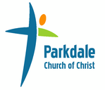
CHURCH PROFILE
October 2018

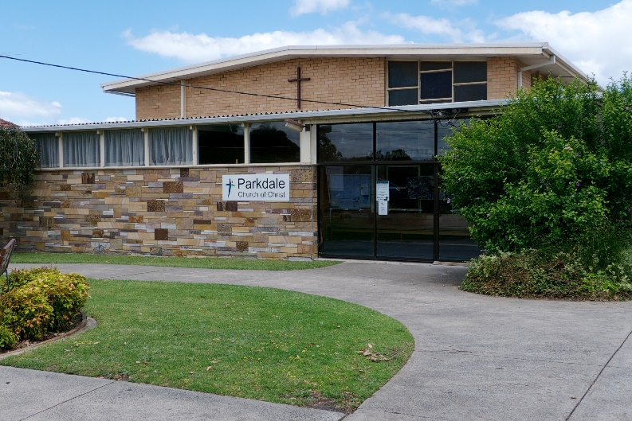
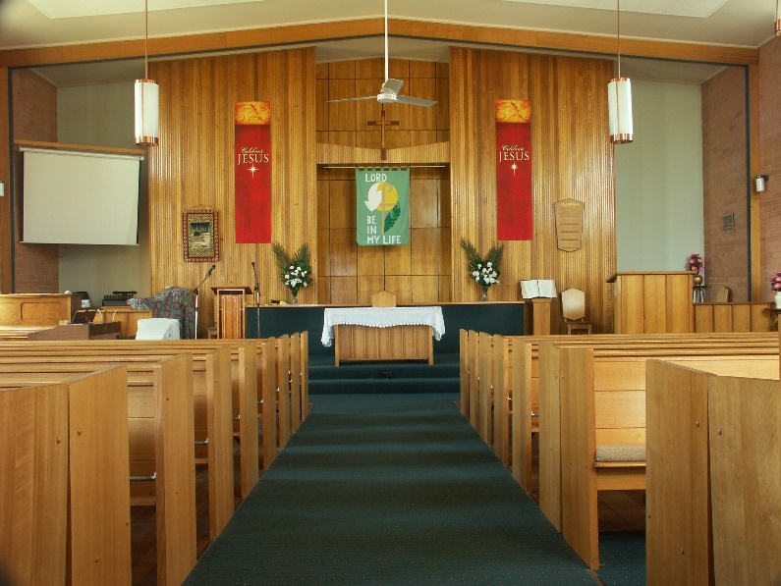

176 Como Parade West, Parkdale
www.parkdalecofc.org.au

Table of Contents

INTRODUCTION 3
Who We Are: 3
OUR HISTORY 4
OUR CHURCH AND COMMUNITY 5
Ministries 6
Our Facilities: 6
Our Connections: 7
What we Believe: 8
Our Mission: 10
Pastoral Priorities 11
Vision for Ministry 12
Current ministries of the church we want to maintain. 12
New directions of ministry which we want to consider. 12
In our Church 12
In our Community: 12
Problems or concerns that might hinder our vision. 12
In our Church: 12
In our Community: 12
How we want our Minister to help implement our vision. 12

INTRODUCTION
Currently we are a church in the process of discernment, seeking God’s will for us as part of his Kingdom in Parkdale. We are looking for a minister who will be able to help us through this process, to motivate, teach and explore with us, to walk the path to which we are being called. Although there are some large challenges before us as a congregation, we all remain united in the desire to seek God’s will and see the growth of his kingdom with action, prayer and love.

Who We Are:
We are a small family church in Melbourne’s South-East.
Our current Sunday morning attendance remains at a fairly consistent 25, with membership numbers at approximately 45. A large proportion of the church family consists of retirees aged beyond 60, which in recent years has made it difficult to run outreach or community programs. The bulk of our populace live within the surrounding area, with a relatively high percentage attending from outside of the immediate neighbourhood – some travelling from as far as Pearcedale and Burwood. We have a number of congregation members from abroad, who attend at specific times of the year due to their travels. These demographics have created some logistical issues in connectivity to the local neighbourhood, however the consistent drawcard that visitors and members continue to describe is the feel of family connectivity and hospitality that is central to our congregation.
Our congregation are predominantly of Caucasian descent, with some exceptions, but we welcome anyone who shares our faith in God regardless of race, age, orientation or any other man-made restrictions.
As a church our corporate structure closely follows CCVT guidelines, with the ministers and the elders providing the spiritual oversight of the greater church. A board of deacons are selected and voted for by the congregation to oversee the church governance. As a church we are signed participants in Affinity Covenant document.

OUR HISTORY
Parkdale Church of Christ was founded in 1921, with 31 members present at the first meeting. The church has occupied the present location since 1923, with the current chapel built in 1964, and the hall complex rebuilt in 1977.
Evangelical tent missions in the 1920s and 1930s increased worship and membership numbers significantly. The Imes Street Sunday school, which opened in 1954, saw Parkdale Church of Christ begin to minister to the children of Parkdale, who lived across Nepean highway, for more than 15 years. Our homecoming/anniversary service has been celebrated in November since 1928. It creates an opportunity to commemorate our history and to invite back members from our past.
Throughout the years our church has been greatly blessed with the support and sacrifice from both faithful members and ministers, which has left us in a favourable situation. We have had the ability, over the years, to support students through their ministry training. This began quite early on in our history, and has continued to this day.
Over the past 25 years, our church has been served by a series of ministers, many of whom have been new in their ministry career. Since 1995 there have been eight ministers at Parkdale:
- Albie Fitt: 1996 - 2000
- Ian Whitlock: 1996
- Cathie English: 1997
- Paul Smalley: 2000 - 2002
- Peter Pitts: 2002 - 2003
- Ian Olive: 2003 - 2005
- Steve Jackson: 2006 - 2018
- Tania Rose: 2013 - 2017

OUR CHURCH AND COMMUNITY
The location of Parkdale Church of Christ is very advantageous with its proximity to the local cafés, beach, schools and public transport such as the trainline and bus stations. The church is located on the beach side of the Frankston train line, with plenty of access for carparking and green space and located alongside several new restaurant ventures in the area. The restaurant and café culture are extremely popular with the locals, with the shopping strip particularly busy on weekends.
The Parkdale area itself is a bayside suburb, which is divided into three areas by local geographical features. The church is located in the segment between the sea and the railway; north of us is the segment between the railway and the Nepean Highway; and further inland of the highway the suburb continues towards the industrial areas of Moorabbin airport and Boundary road.
Parkdale’s population sits around 11,746, with the median age at 42 (Census data, 2016). 50.4% of the population is married, 8.7% divorced and 5.5% widowed (Census data, 2016). 74.2% of people were born in Australia, with the next highest percentage being 5.1% born in England, however a large proportion of the population stated European ancestry (Census data, 2016).
A portion of the Parkdale’s population is of an older, retired demographic, but these are being slowly supplanted by a younger family demographic. We are seeing an increase of new immigrants of European backgrounds with two working parents and high levels of education. This newer population retains strong cultural ties to their backgrounds and have created their own communities in which to socialise within the Parkdale space.
Our demographics, described in terms of CCVT guidelines, are as follows:
Our location is best described as being a stable residential urban neighbourhood, with a rapidly growing community in a local suburb.
Approximately 50% of our congregation live within 2 km of the church, but over 43% of regular congregants live more than 5km distant, some coming from relatively long distances.

Age Category
0-12 (Preschool / Primary School) | 6
26-40 | 4
41-50 | 4
51-60 | 2
61-70 | 5
71+ | 18
Column Totals | 39

Employment Status
Employed full time | 3
Employed part time | 6
Homemaker full time | 1
Retired | 23
Student | 6
Column Totals | 39

While our church demographics are in some respect’s representative of the local area, a notable gap is in the lack of families and young people attending. The larger part of our congregation are parents with no children left at home. The majority are retired, with a small number of children regularly attending.

Ministries
Our Sunday morning worship service at Parkdale follows a fairly typical form, with no fixed liturgies and the various roles of the service being filled by members of the congregation. Our musical worship is usually a blend of traditional hymns and somewhat more contemporary spiritual songs led by a song leader/team supported by a mix of piano/guitar/drums.
The bulk of the preaching /teaching remains the role of the minister. We do support our lay members in bringing a message if wished.
We run a children’s talk within the service as well as a Sunday school that encompasses the mostly school aged group we have, although due to lack of numbers we no longer run a separate creche. We strongly encourage the children within our congregation to take ownership of their own segments of the service, with some taking the initiative to occasionally lead the children’s talk themselves.
Our communion table is open to all who share our faith in Jesus and is led by various of our members. We strongly believe and support the ministry of all believers however in practise these roles within the service, and the spiritual oversight of the church, are generally over seen by the eldership and supported by the minister.
Sunday evenings most weeks we also run an evening service of a more reflective nature. This has traditionally been run and organised by the minister and has had a more ‘spiritual’ feel. In the past this time has been used to explore more meditative styles such as the Lectio Divina. At other times in the past this time has also been used as a further time of worship in song. This group is a far smaller gathering than the Sunday morning worship but offers a strong style difference.
Visitation has also typically been done by the minister and elders. There is in place a prayer chain and team to support the congregation and other petitioners through prayer.

Our Facilities:
As the church has evolved in the same space since 1921 there have been multiple additions and renovations to serve the church and the community along the way. The most recent of these was the alteration to the entry space and kitchenette addition over 15 years ago. The space we have is versatile with dedicated worship and gathering spaces, plenty of parking and tennis courts (which have been utilised for community connection in the past). There is a dedicated manse which has had recently upgraded heating/cooling. The buildings, though well utilised throughout the week, are deteriorating with greater money needing to be spent to either maintain or upgrade them within the foreseeable future.

Our Connections:
Over the past years we have had strong ties, and several successful missional experiments with several of the regions other church communities, in particular a history of co-operation with the Parkdale Uniting Church, St Aidan’s Anglican and Mordialloc Baptist. Parkdale has in the past been involved in local ecumenical Easter Sunday services, and has been a member of a joint youth group with local Anglican and Uniting congregations.
However, for a variety of reasons these ties are no longer as strong as they once were and most co-operative efforts have now been relegated to history with the exception of the Easter Morning Beach service which remains an interdenominational effort, run by the congregants rather than through church hierarchy.
Various groups use our church facilities during the week: our hall is used by a local theatre group, a local playgroup and a children’s music program and other community groups. There is also a large local Oromo congregation that uses our chapel and facilities twice a week.
We maintain connections with Parkdale Secondary college, as well as with a number of community-based charitable organisations.

What we Believe:
As a Church of Christ, we hold to the principle of our movement in general terms; in essentials unity, in non-essentials liberty, in all things love.
With this in mind, here are the details of some of the stances of our congregants.
We believe in the trinity, One God, creator father; his son Jesus, messiah saviour; and the Holy Spirit, helper, indwelling the believers for the building up of God’s church.
We believe in ‘being’ the Church, a group of people unified in faith to live out the kingdom in worship and service.
We believe in the ministry of all believers; in the gifts of the Spirit. To each given a different gift according to the will and purpose of our God for the building up of the body.
We believe in the great commission, the underlying purpose of Christs’ Kingdom, to go out and make disciples of all peoples.
God
Creator of the universe, and personally cares for us and our well-being. Primarily desires our worship and adoration.
Jesus Christ
The Son of God, but also God in himself. Made the sacrifice of His life for our eternal salvation.
Holy Spirit
The third “person” of God, the indwelling spirit.
The Bible and its use
General agreement that scripture is divinely inspired and “useful for teaching” (2 Timothy 3-16). We appreciate scripturally-based teaching that brings to life the context in which it was written and shows application to daily life.
Baptism
Baptism is by full immersion and the outward expression of an inward change. A commitment of faith, made as a public declaration.
The basis for welcoming people into the church membership
Baptised Christians who choose to worship with this community.
Lord's Supper
A ritual of remembrance as commanded by Jesus at the Last Supper. We do not believe it is necessary for salvation, but we believe it should be shared at least weekly.
The human condition
Humans are made in the image of God, but sinful and fallen and need the saving grace of Christ.

The purpose, place and mission of the church in today's society
The Church should be the pinnacle of ethics and morals, defenders of God’s word and will. The church should have a prophetic voice (moral compass) for society.
The church is also a group for the support and empowerment the people of God, a place to share in sympathetic company.
Another main purpose of the church is to enable the exaltation of God, as a gathering of worship.
The role of the laity
We believe in the “priesthood of all believers” and believe that all church members should have freedom to participate in aspects of Church life. From preaching and presiding to the running of outreach, we value the freedom (and support) to operate on our own.
The role of the minister
The minister is a leader, teacher and supporter. Their role is to encourage, equip and empower the membership. The minister should be a source of general direction, deep scriptural knowledge and wisdom.
Your commitment to support of the Churches of Christ movement in Victoria and Tasmania
We are affiliated with CCVT and support its policies such as those concerning ministry, safe churches and codes of conduct. Generally, we respect the CCVT but occasionally suspicious of its motives. We don’t feel it always makes the best decisions or has the best interests of a specific congregation at heart.
The place and importance of prayer
Prayer is fundamental to the Christian life and is an integral part of Church practice both within worship services and in all other gatherings.

Our Mission:
Parkdale’s official mission statement reads:
“Our mission is to live out the Gospel of Jesus Christ in the midst of our community, so as to invite others into a journey of faith and renewal leading to a relationship with Jesus.”
We implement this by;
- Presenting the Gospel in a way that people can easily understand.
- Discovering the needs of the community and how we can meet them.
- Maintaining our community as a welcoming place for people in need.
- Providing people with inspiration and motivation in their spiritual lives.
- Encouraging people to use their gifts.
- Encouraging people in their personal worship.
As a church, our current focus has been trying to create new ties within the local community, with initiatives and community events such as the Community Garden Beds, Music Nights and community events being bigger investments of time and resources.
Alongside these more visual opportunities we also run many other activities such as the Book Club, Discussion Groups, Ladies Lounge and Craft Group and Friendship Centre. Some of these groups have been running for many years and service a set of regulars from the local area and church community. In the past, Friendship Centre has been very successful in attracting attendees from outside of the church.
Through these ministries, as with past programs like youth and play groups, we are seeking to connect with the community outside of the church. We hope to see growth while maintaining the balance of community and connectedness that our history has allowed us to create.
We are seeking to revitalise our impact on our local community, with new ministry outreach and build our own community with confidence of the gifts we’ve been given and the knowledge of our God’s invested interest in our mission.

Pastoral Priorities
In 2018 we engaged with the congregation to determine the priorities for Parkdale’s ministry efforts in the immediate future. The following priorities were clearly identified as being important activities for Parkdale and will be sought in a new ministry candidate.
 | Evangelism | Seek to lead persons to make decisions for Christ
 | Interpreting the Faith | Communicate a comprehensive understanding of the Bible and Christian theology in terms relevant to persons’ lives
 | Preaching | Support the preaching ministry with time for preparation/reflection on the Word and commitment to listen for the Word’s power and its implications for individuals, the church, the community and the world.
 | Pastoral Care and Visitation | Provide by word and presence an empathetic understanding of and concern for persons in routine and joys as well as the crises and transitions of life, giving assistance where appropriate and feasible.
 | Nurturing Fellowship | Create an atmosphere in which persons feel accepted, cared for and included in the group
 | Spiritual Development | Provide opportunities for individuals or groups to understand and enhance the spiritual dimensions of their personal lives
 | Church Growth | Enlarge membership and/or the vision and ministry of the church
 | Community Action | Identify and evaluate the needs of the community and work to meet those needs through individual and/or corporate action. Work with other language, ethnic or cultural groups

Vision for Ministry

Current ministries of the church we want to maintain.
Most or all current activities of the church are valued by members of the congregations. These ministries include:

- Morning service and evening gathering
- The Friendship Centre
- Book club
- Cuppa and Craft
- Discussion Groups
- Community gardens
- Music events
- Community events

New directions of ministry which we want to consider.

In our Church

- Bible studies / groups
- Youth group
- Wider pastoral support
- Church family activities

In our Community:

- Needs-based outreach
- Community events expanded

- Home or hospital help
- Mission work in our local area

There is a general desire for the church to be community-connected but little knowledge or agreement on the specific needs or approaches.

Problems or concerns that might hinder our vision.

In our Church:
- A lack of sufficient people is the primary identified challenge
- Geographic distribution / distance
- Poor planning and/or communication skills
- Difficulty letting go of the past
- Internal conflicts

In our Community:
- Needs in our community are not obvious / material
- Poor community attitude to “church”, religion and faith
- Lack of immediate community connections

How we want our Minister to help implement our vision.
- Strong support to encourage and help us engage with the community
- Participate through leadership and encouragement
- Be involved (from observation to leading) with all activities

